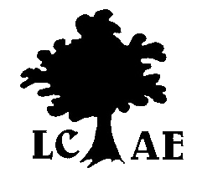

LONDON COUNCIL FOR ADULT EDUCATION
Galleria Postal Outlet • P.O. Box 23174, 355 Wellington St. • London, ON • N6A 5N9
Serving Adult Learners since 1945

General Membership Meeting
March 20, 2012

The meeting was held at Goodwill and attended by 15 people. The topic was Clear Writing – how to write so people will understand. The presenter was Anne Marie Curtin of Literacy Link South Central.

Click the slide below to view presentation:

Agency updates were provided. All members were invited to submit for the meeting minutes.

ALPC Update:

